**Validate mode option in Copy into command**

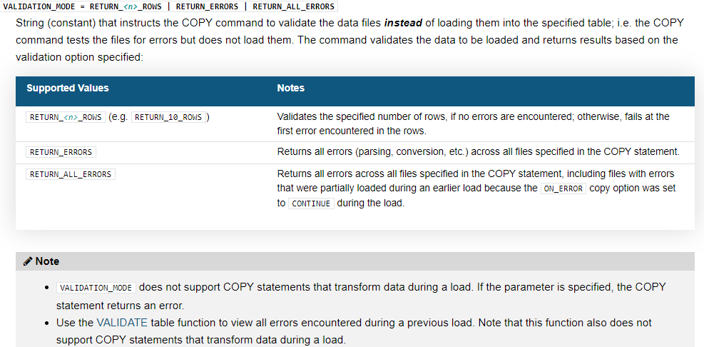

The COPY command supports:

* Column reordering, column omission, and casts using a [SELECT](https://docs.snowflake.com/en/sql-reference/sql/select.html) statement. There is no requirement for your data files to have the same number and ordering of columns as your target table.

### Load a Subset of Table Data

Load a subset of data into a table. For any missing columns, Snowflake inserts the default values. The following example loads data from columns 1, 2, 6, and 7 of a staged CSV file:

copy into home_sales(city, zip, sale_date, price)

from (select t.$1, t.$2, t.$6, t.$7 from @mystage/sales.csv.gz t)

file_format = (format_name = mycsvformat);

### Reorder CSV Columns During a Load

COPY statement uses the [SUBSTR , SUBSTRING](https://docs.snowflake.com/en/sql-reference/functions/substr.html) function to remove the first few characters of a string before inserting it:

copy into home_sales(city, zip, sale_date, price)

from (select substr(t.$2,4), t.$1, t.$5, t.$4 from @mystage t)

file_format = (format_name = mycsvformat);

### Convert Data Types During a Load

*Convert the staged CSV column data to the specified data types before loading it into the destination table*

copy into casttb(col1, col2, col3)

from (

select to_binary(t.$1, 'utf-8'),to_decimal(t.$2, '99.9', 9, 5),to_timestamp_ntz(t.$3)

from @~/datafile.csv.gz t

)

file_format = (type = csv);

**RESULT_SCAN Table function**

Returns the result set of a previous command (within 24 hours of when you executed the query) as if the result was a table.

The command/query can be from the current session or any of your other sessions, including past sessions, as long as the 24 hour period has not elapsed.

select last_query_id(-2); -- 2nd most recent query_id

Retrieve all values from your second most recent query in the current session:

select * from table(result_scan(last_query_id(-2)));

Retrieve all values from your first query in the current session:

Select last_query_id(1); -- get first query of current session

select * from table(result_scan(last_query_id(1)));

Retrieve the values from the c2 column in the result of the specified query:

Result scan in comination with Describe and show commands

select c2 from table(result_scan('—pass queryid here --'));

desc user SKILLSCALER1;

select "property", "value" from table(result_scan(last_query_id()))

where "property" = 'DEFAULT_ROLE';

**Extract empty tables that are older than 21 days from show command**

show tables;

-- Show the tables that are more than 21 days old and that are empty

-- (i.e. tables that I might have forgotten about).

select "database_name", "schema_name", "name" as "table_name", "rows", "created_on"

from table(result_scan(last_query_id()))

where "rows" = 0 and "created_on" < dateadd(day, -21, current_timestamp())

order by "created_on";

# VALIDATE Table function

Validates the files loaded in a past execution of the [COPY INTO <table>](https://docs.snowflake.com/en/sql-reference/sql/copy-into-table.html) command and returns all the errors encountered during the load, rather than just the first error.

select * from table(validate(<table_name>, job_id=><query_id_of_the_copy_command>));

JOB_ID => query_id

select * from table(validate(emp, job_id=>'_last'));

If _last is specified instead of query_id, the function validates the last load executed during the current session, regardless of the specified target table.

This function does not support [COPY INTO <table>](https://docs.snowflake.com/en/sql-reference/sql/copy-into-table.html) statements that transform data during a load.

The validation returns no results for COPY statements that specify ON_ERROR = ABORT_STATEMENT (default value).